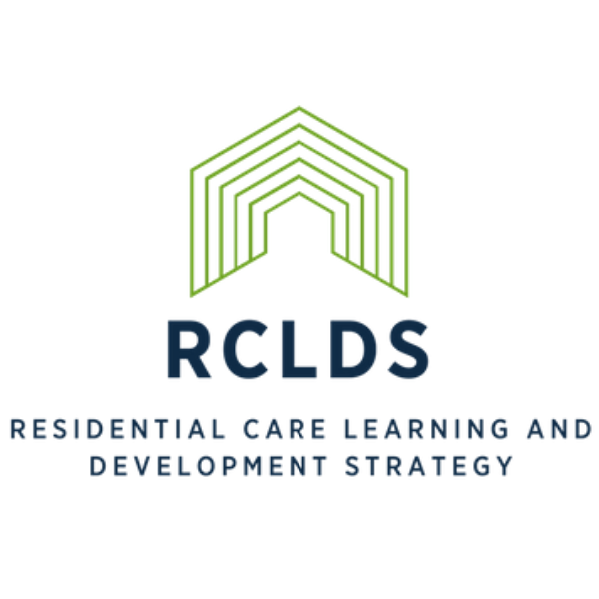
RCLDS Further Education Scholarships 2020/2021

Application Information
The Residential Care Learning and Development Strategy, Further Education Scholarship offers financial support for the on-going higher education of people working in the residential care sector.

Aim of the Scholarship
The aim of The Residential Care Learning and Development Strategy is to continue to support the improvements in residential care service provision, by supporting residential care workers who have a Certificate IV in Child Youth and Family Intervention (Residential and Out of Home Care) or similar to obtain a relevant Diploma or Undergraduate Degree.
Successful applicants will be offered up to $2,000 which is to cover fees and essential books. Funds will be made available upon proof of enrolment.

Selection of Successful Scholars
The decision about who will receive a further education scholarship will be made by a sub-committee of the RCLDS Reference Group. Their decision will be final and no correspondence related to their decision will be entered into.

Successful Scholarship Applicants
The successful applicant must begin their studies in the year of application.
Successful applicants are to ensure holidays are pre-planned and the course is completed in the year the Scholarship has been awarded.
Successful applicants will need to provide permission for their names to be published to the sector, which may include attendance at Resi Rocks for an official presentation, including photos.

Selection Criteria
The Scholarship will be offered to applicants who are, or will be undertaking tertiary study relevant to residential care practice and must be studying an accredited tertiary course (such as Diploma or Undergraduate Degree) in an area which supports improvements to the practical provision of residential care service .
The applicant must be employed by a Community Organisation funded by DFFH Out of Home Care, to provide youth residential care services in Victoria.
The applicant must have been employed in the residential care sector for at least two or more years.
Applicants must occupy a role where their studies directly benefit children and young people in care such as a direct care Residential Worker, unit-based Supervisor, or Residential Care Managers.
The applicant must not have previously received a RCLDS scholarship.
The application must be accompanied by a letter of support from the applicant’s employer and signed by relevant manager.
In the case of multiple applicants from the one organisation, the selection committee will seek advice from that organisation as part of the assessment process.

Name, Contact and Employer Details

Name
Title | Mr/ Mrs/ Miss/ Ms/ Other…..
First Name
Surname
Contact Details
Work Phone
Mobile
Email
Employer
Organisation Name
Organisation Address
Manager
Email
Phone Number

Employment & Qualifications

Length of employment in the sector
Current title and role in the sector (please describe the nature of your direct contact with children and young people in residential care)
What are your current qualifications and where did you get them from?

Course Details of Application

Title of proposed course of study and qualification to be attained on completion of study?
Education institution you will be studying at?

Enrolment Status

Enrolled and part of the way through the course
Enrolled and commencing the course
Application in but not yet enrolled

Date of course commencement
Anticipated date of course competition

Funding Breakdown
Funds applied for (up to a maximum of $2,000)
Course Fees | $
Course Materials | $
Other (include details) | $
TOTAL | $

Please describe the subjects within your proposed studies:
Please explain why you have chosen these studies:
What form do your studies take? (e.g. formal paper, lectures, tutorials, on-line, correspondence etc.)
How do you plan to share this information with the sector? (e.g. information session, website, conference paper):
Other relevant information that will add to your application:

Declaration to be signed by applicant

I declare that I am eligible, according to the selection criteria and agree to the conditions of this funding as stated in the Residential Care Learning and Development Strategy (RCLDS) Further Education Scholarship 2020/2021 Information Sheet.
I commit to completing the Course of study stated in this application and declare that all information supplied in this application and any attachments is, to the best of my knowledge, accurate and complete.
If I am successful in my scholarship application I consent to my name being published within the residential care sector by the Centre for Excellence on behalf of the RCLDS Reference Group and may be required to officially be presented my scholarship at the annual Resi Rocks forum in September.

Signed: __________________________________________

Name: __________________________________________

Date: __________________________________________

Application completion checklist

Information sheet read and understood
Form completed
Declaration signed
Letter of support from Manager attached

Please send your completed application form and any attachments to RCLDS@cfecfw.asn.au

